­­­­

Problem Statement-1: How It Works

Table of Content



JAVA SPRING BOOT-I

4

5

**THANK YOU**

1

3

**PROJECT EXECUTION SCREENS**

**PROJECT EXECUTION**

**PREREQUISIITE**

**PROJECT STRUCTURE**

2

**Prerequisite**

1. Latest and stable version of Spring Tool Suite or Eclipse should be installed
2. Java should be installed
3. Maven should be installed
4. MySQL Workbench should be installed

**Project Structure**

**UI**

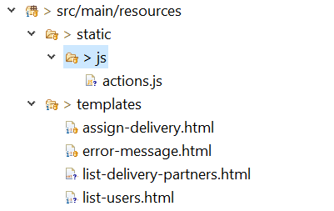

**API**

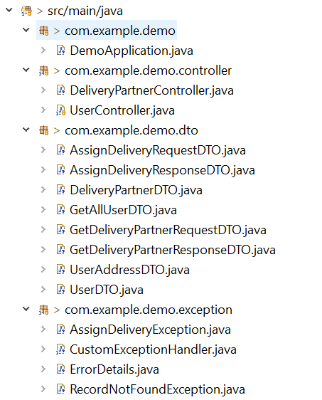

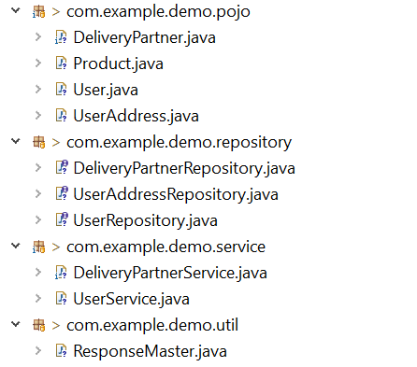

**Database**

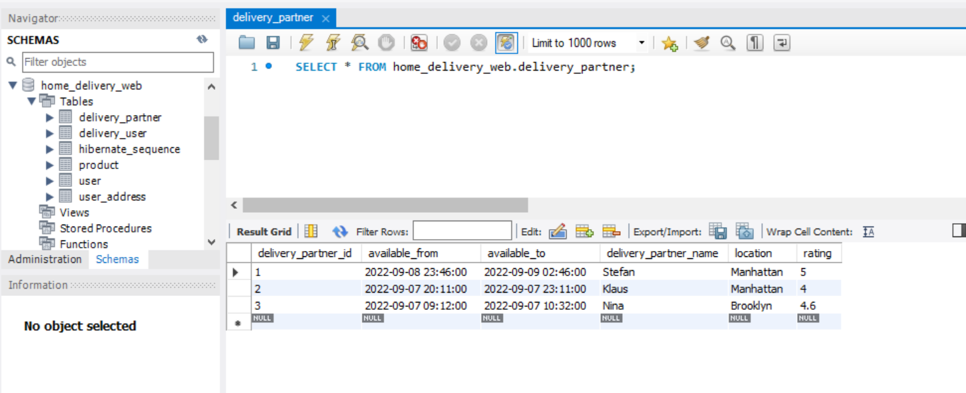

**Project Execution**

1. Import the project to IDE
2. Update the Maven Dependency
3. Import the database
4. Run the project as spring boot application

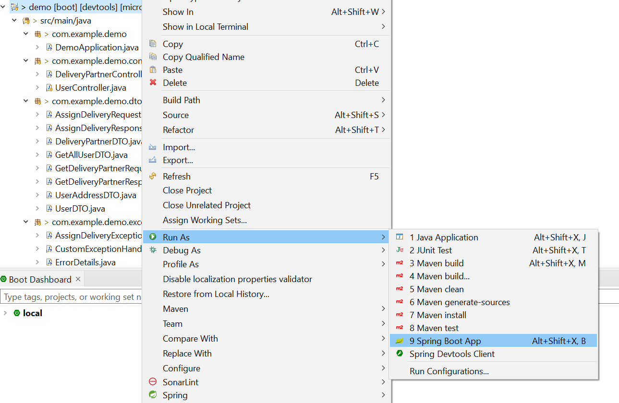

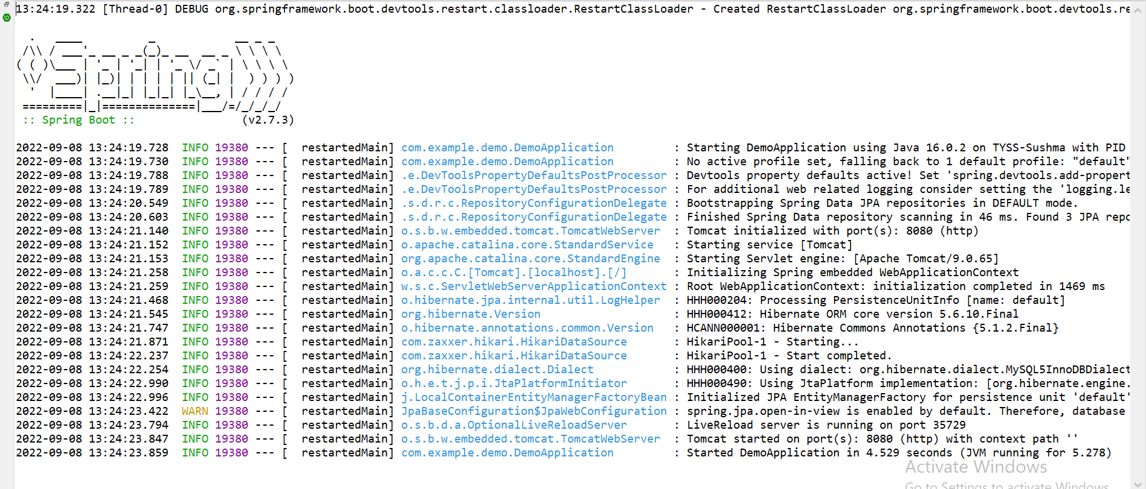

Open browser with Project URL: **http://localhost:8080**

**Project Execution Screens**

**1.** Home Page

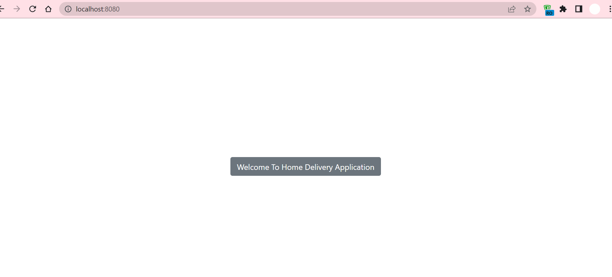

**2.** All the user details will be displayed after clicking on welcome button.

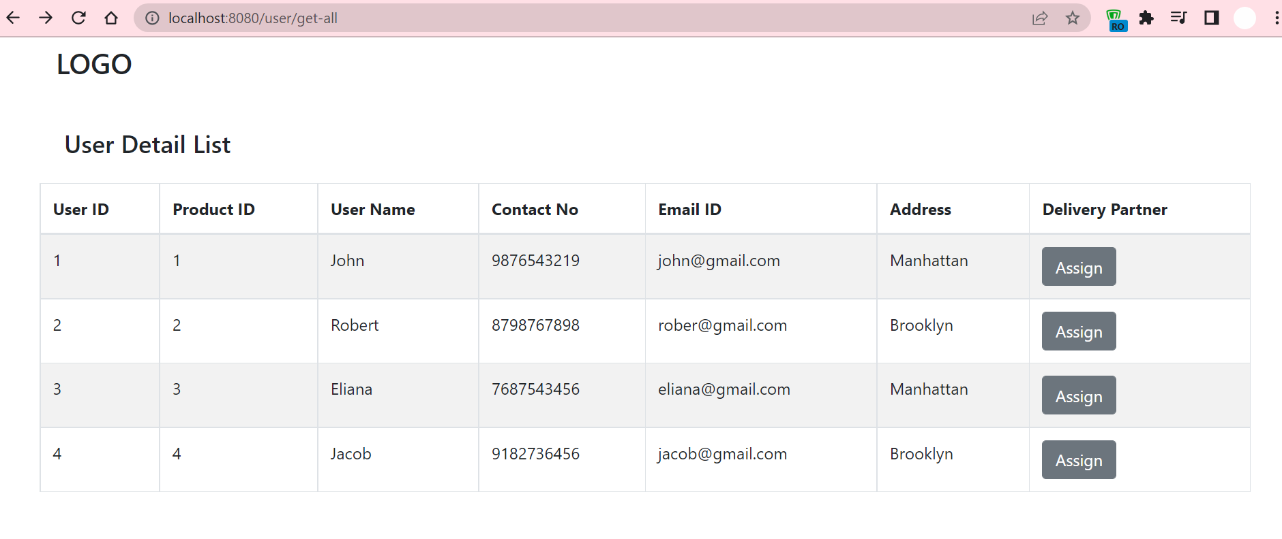

When we hover on Delivery partner’s name, his availability will be displayed as tooltip.

**2**. After clicking on **Assign** button, all the available delivery partners will be displayed.

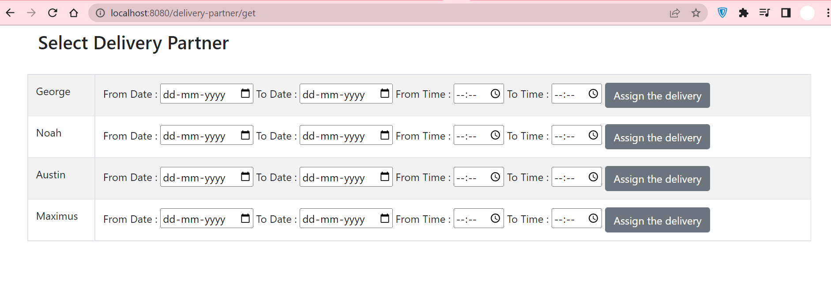

**3.** User can click on **Assign the delivery** button after selecting required date and time.

Negative Scenario: If the delivery partner is not available, error message will be displayed.

After clicking on **Go** **Back** button, user will be navigated to **Select Delivery Partner** page.

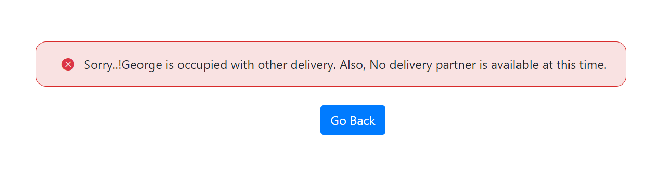

Positive Scenario: If the delivery partner is available, success message will be displayed.

After clicking on **Go** **Back** button, user will be navigated to **User Detail List** page.

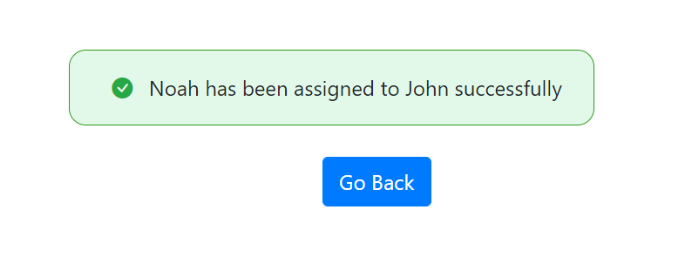

**4**. Database: Before assigning the user to delivery partner.

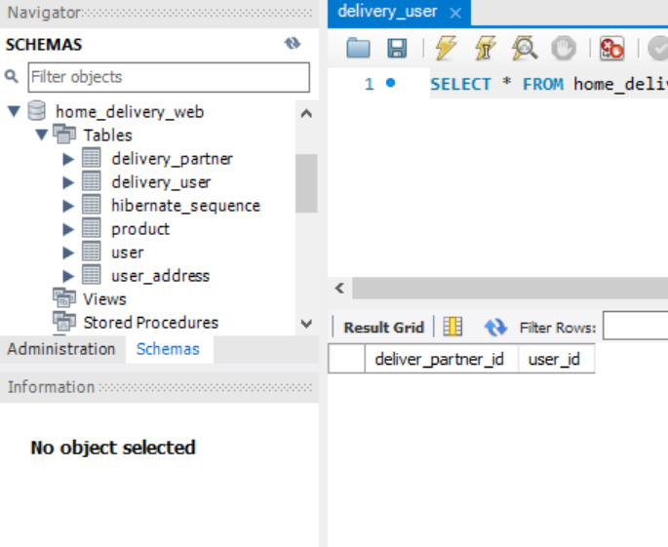

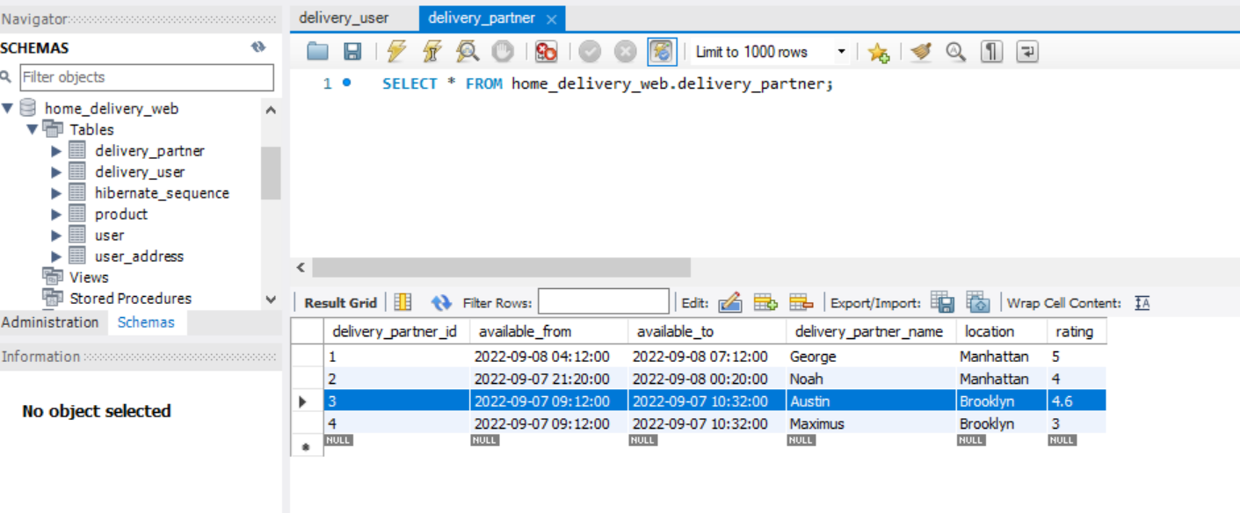

After assigning the user to delivery partner.

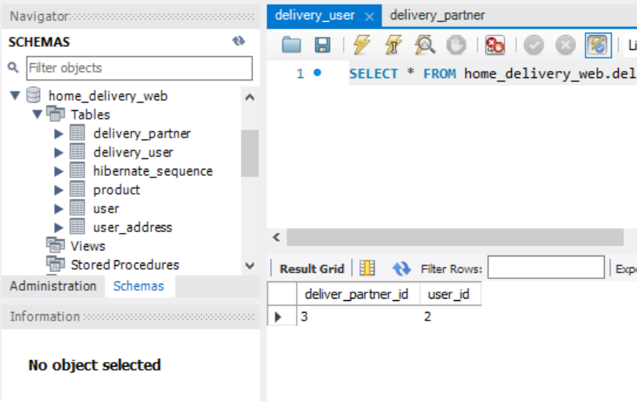

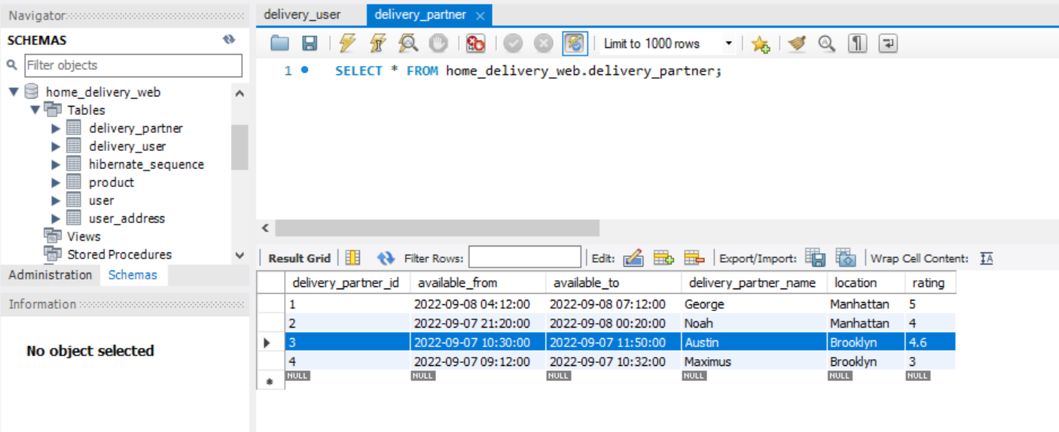

**Thank You**